Question2: std. dev= 100

n = 25

sample mean= 520

confidence interval= 80%

α= 1- 0.80 = 0.20

lower fence = point estimate – margin of error

higher fence= point estimate + margin of error

where, point estimate is the sample mean and,

margin of error = $z_{α/2}*\frac{σ}{\sqrt{n}}$ **= 1.28 * 100/ $\sqrt{25}$**

= 1.28 * 100/5 = 25.6

Lower fence = 520- 25.6 = 494.4

Upper fence = 520 + 25.6 = 545.6

Question3:

a)null hypothesis :

$H_{0}:p ≤$ 0.6

$$i.e the percentage of citizen in the city that own a vehicle is less than or equal to 60\%.$$

Alternate hypothesis : p $>$ 0.6

b)

Significance value is 10% , which means that the confidence interval is 90%:

C.I. = 1- 0.10 = 0.90 ( 90%)

n = 250

number of residents owning a vehicle = 170

hence, the percentage of people owing a vehicle in the survey = 170/250 * 100 = 68% ( p= 0.68)

population percentage is than or equal to 60 ( 0.60)

Z = P (sample) – P (population)/ sq. root of P population( 1- P population)/n

Using the Z table for a significance of 0.1 ( 10 percent)- 0.1 /2 = 0.05

the decision rule : range -1.64 to + 1.64

Z value for the proportion using the above formula = 0.08/0.031 = 2.58

The value lies outside the calculated range for the given significance values. Also, selecting any value below 60 percentage (as per the null hypothesis) would give a larger difference between the probability with respect to the sample and the population. Which would always be higher than 2.58, which is outside the range.

Hence, the null hypothesis is rejected here. We don’t have evidence to support the idea that vehicle owners in the city is 60 percentage or less.

Question4;

2,2,3,4,5,5,5,6,7,8,8,8,8,8,9,9,10,11,11,12

N= 20

Value for 99 percentile= ?

Q ( index value) = percentile/100 * (N+1)

= 99/100 * (20+1) = 20.79 index

Which points to : **12**

**Question 1 : Plot the histogram**

10, 13, 18, 22, 27, 32, 38, 40, 45, 51, 56, 57, 88, 90, 92, 94, 99

**With bin: 5 and bin size =20**

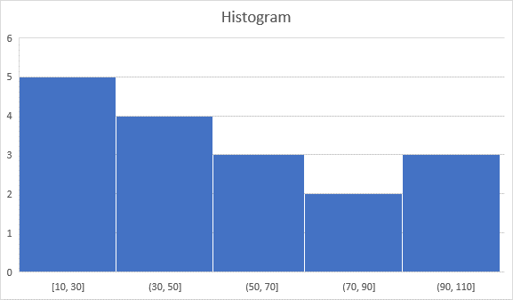

Question 5:

